**SERMON: On the Bondage of the Will August 4, 2024**

**INSERT**

Erasmus was a humanist. “We have it in us to ‘better’ ourselves.” And, as a humanist, believing in man’s potential, he will advise you how to do it. The church and the bible is a great help in achieving the betterment of humanity. But, that is all it is. Jesus did not perform miracles, or any supernatural acts. He also was not a prophet. Look at him as a transcendent being whose simple way of life, whose humility and compassion is an example to you, to change your life and follow a more pious way.

Erasmus was famous. Many argued that not since Cicero (century before Christ came), have we seen such an intellectual figure as Erasmus. He proposed a new curriculum for Europe, with Latin and Greek at its core. His educational program was highly elitist - he did not care about ordinary people and how to train them to lead a productive life. He wanted to train the aristocracy of culture and taste and they could guide the rest of society. His curriculum became the basis for upper-class schooling in Europe until well into the 19th century. “Scholars,” Erasmus wrote, “should confine themselves to the classics, and languages such as Latin and Greek, and this you can only learn in reading and writing.” Meaning, as a scholar do not depend on ordinary people. The people are poor custodians of quality. In short, Erasmus, seen by many as “the champion of a common people,” was a world-class snob.

The dispute between Erasmus and Luther had to do with the starting point of Reformation theology, with the radical view of sin and bondage of the human will in respect of grace. Erasmus talks differently about “original sin’ than Luther. Your view of sin will tell what you think of “free will,” or, “the ability of man” to make a conscious decision for Christ. Erasmus said, “man has the ability.” Luther said, “man is dead in his trespasses” (Ephesians 2:1).

For Erasmus, renewal of society starts with man who has the freedom to choose what they will do, without the interference of God. The renewal of the church, and society for that matter, lies in the will of man. Man can do this, if only he wills, and man has a beautiful example to follow, the teaching of Jesus in the Sermon on the Mount. The focus in the Sermon on the Mount, Erasmus argued, lies in “lifestyle.” All comes back to man making a decision to live a better life for the betterment of society, and Jesus gave us instruction in the Sermon on the Mount how to do just that.

Erasmus was not a man who wanted to be too precise. Read the bible, but do not believe everything you read, he would argue, for that would be too radical. He did not like to differ. He wanted to sit down with a glass of wine, talk about life, listen to different views and opinions, but, to be precise and rigorous, as Luther, that did not work for him.

If you come to know Erasmus, you will come to know Melanchthon. Very similar in their take on life - always changing what they wrote - words are only on paper, and it can be changed. Noting is precise, nor definite. So, nobody is right; nobody is wrong. It is all about the exercise of reading, and discussing. Only to better ourselves as we then can better others.

And then came Martin Luther! And he was precise. Luther appreciated Erasmus writing on “The Freedom of the Will,” for Erasmus was not dealing with some trifling matter in this writing. “This is it,” Luther cried out. “Now we are talking.” *“Aquila non caput muscas”*. “The eagle does not catch flies,” the saying goes. Melanchthon, according to Luther, was not catching flies.

However, in his writing we learn that Erasmus did not like Luther to be “so clear,” for clarity brings division. By being clear, by asserting that you are confessing the truth, you imply that someone else is not. For Luther, and this is what we are looking at today, a Christian asserts (confesses) the truth. Even though he differs with others. And you need to learn how to live with that.

**SERMON. Romans 10:1-17**

We could be students of the bible, know the bible very well, and still not believe that it is the Word of God, and that God speaks to us as we read his Word. Erasmus knew the bible very well, but did not believe that it is the Word of God. It is an ancient text, and he could use it and learn from it. He could become wiser and had no problem with that. Erasmus was quite happy to go along with whatever decisions the church made, based as they said, on the bible, not that he believed it nor that he followed it.

**Erasmus did not like Luther’s ‘over-bold’ assertions**. He did not like that Luther would staunchly hold his ground, state his position, confess it, defend it and preserve it. For Luther the bible is delivered to us from above. God gave it, therefore, follow it. And the bible is full of assertions - it is a statement, a claim made by the Creator of the universe.

And since it is the Creator God who gave it, who also gave his Son, Luther followed every word God said. He believed Jesus when Jesus said to Mary Magdalene in **John 20:17**, *“Do not cling to me for I have not yet ascended to the Father, but go to my brothers and say to them, ‘I am ascending to my Father and your Father to my God and your God.”* The true Moses does not leave Egypt alone, but takes all of Israel with him.

This is the truth, and this truth excludes all Egyptians, all people who did not go with Moses of old to the promised land, and all peoples for whom God, the Father of Jesus Christ, is not God. **So, Erasmus, Luther would say**, *“I am holding my ground and confess, Jesus is the Christ, and He is the ‘Way.’”* If you want to be with God, to ascend to God, then the only “way” to be with God is Jesus for He is ***“the Way.”***

**This is a strong assertive way of speaking.** It is not only in the Gospels that you find the claim made that Jesus is the Way, the Truth and the Life, it is also the apostles that says: *“Be certain of that,”* Paul goes to say, *“With the mouth confession is made unto salvation”* **(Romans 10:10).** And so Christ said in **Matthew 10:32**, *“Whoever confesses me before men, him will I confess before my Father.”*

**If we speak the way the Bible speaks,** which is the Word of God, then *assertions is most characteristic* for a Christian. “*Take away assertion,”* Luther writes, *“and you take away Christianity.”* The Holy Spirit is given to Christians from heaven in order that He may glorify Christ and in them confess Him even unto death - and is this not assertion, too die for what you confess and assert? A Christian does not deprecate (*belittle*) assertions. If we do we would deny all religion and piety in one breath, asserting that religion and piety and all dogmas are just nothing at all.

**Erasmus preferred to be a likeable person, a nice guy**. Someone who respects the view of others without having a view himself. He would rather doubt all truths, than belief in something specific. Sounds very much like the culture in which we live today. Everything people believe is true for them. Who am I to differ? If I believe in nothing, then the more I am accepted. Beware if you believe in something - you might just offend someone!

**Erasmus will speak from both sides of his mouth**. He will say, *“I stand under the authority of the Scriptures and the church, and its decisions.*” And then he would say, *“I want to be free to assert to nothing about all the things Scripture and the church says.”* We easily say with Erasmus, *“I believe I receive Christ body and blood, orally, through my mouth.”* And then we attend a protestant church and say with protestants, *“I do not receive Christ at all in the Lord’s Supper. It is only a sign.”* And we have no problem when we say that, for one or other way, we lie. And that is ok. Hello Erasmus!

**Luther could not do this.** He said to Erasmus, “As a Christian, I will make it my variable rule steadfastly to adhere to the sacred text in all that it teaches, and to assert that teaching. And also. I want to be clear as to what the Scripture does not say, for uncertainty is the most miserable thing in the world.

**Erasmus said he would gladly submit to the authority of the church** and all that they ask him to believe and do. This does not make sense at all for Luther. *“Isn’t it enough to submit your judgment to Scripture,”* he asked Erasmus. “*Do you have to submit it to the Church as well? Do you want to tell me that the Church needs to settle something that Scripture already did? Think about what you are saying: Do the Church judge Scripture, or do Scripture judge the Church?”*

**Luther summarized Erasmus thinking this way.** “I tell you what it is that you say: That you do not think it matters a scrap what anyone believes anywhere, so long as the world is at peace; you would be happy, for anyone who’s life, reputation, welfare or influence was at stake to emulate him who said; ‘If they affirm, I affirm; if they deny, I deny.’ And then you would encourage such a man to treat Christian doctrines as no better than the views of human philosophers.”

**“Your motto,”** Luther said, is, *“What is above us, does not concern us.”* You want us to stop fight over things that does not concern us, according to you. I get the idea, that you are amused by us who believe in God and confess him to be our Creator, and our Saviour.

Erasmus was indeed a biblical scholar, but he **so detested conflict** that he refused to let the Scriptures speak for themselves. For all his love of eloquence, the Bible’s clarity meant little. His *“Philosophy of Christ”* was based on nothing more than what most people today would call **“religion”:** an inarticulate preoccupation with being a good person.

**In our individualistic modern western society Erasmus would be the champion**. According to our society, Erasmus was a man ahead of his time. Luther’s love of theology and doctrine is not popular. To let Christ speaks for himself, *“I am the Way, and the Truth, and the Life. No one comes to the Father except through me,”* is not acceptable - has never been. It is too assertive, and it is too clear.

We teach the way Luther taught and wrote. If we hide that we are justified through faith in Christ alone, we hide Christ’s glory and benefits. We are robbers, as Erasmus was robbing people from hearing that through Christ they are justified, through Christ they are saved.

**In the Apology to the Augsburg Confession** (Article IV, par. 7) we hear, “*our adversaries choose the Law and by the Law they seek forgiveness of sins and justification.*” Erasmus surely had a home in the Roman church, for he championed the same position.

**AMEN.**

For Luther, it is unthinkable to assert to nothing, and then think of yourself as being “over-and-above” the things people assert. By having such a “lofty” position, you fool yourself, for you look down on those dumb people whose life depend on certain “assertions” or “beliefs” they hold. For Luther, Christians delight in assertions. Erasmus, on the other hand, find pleasure in not having any assertions.

Luther explained it this way. “With ‘assertion” I mean staunchly holding your ground, stating your position, confessing it, defending it and preserving in it un-vanquished/undefeated.” For Luther the term has no other meaning, and he is talking about the assertion of what has been delivered to us from above in the Bible.

Think of the Apostle Paul. How often does he calls for “full assurance” which is, simply, an assertion of conscience, of the highest degree of certainty and conviction. In **Romans 10:10** he calls it *“confession”* - *“with the mouth confession is made unto salvation.”* Christ says, *“Whoever confesses me before men, him will I confess before my Father”* **(Matthew 10:32)**. Peter commands us to give a reason for the hope that is in us **(1 Peter 3:15).**

Nothing is more familiar or characteristic among Christians than assertion. “Take away assertion,” Luther writes, “and you take away Christianity.” The Holy Spirit is given to Christians from heaven in order that He may glorify Christ and in them confess Him even unto death - and is this not assertion, too die for what you confess and assert? A Christian does not deprecate (belittle) assertions. If we do that we would deny all religion and piety in one breath, asserting that religion and piety and all dogmas are just nothing at all.

Luther said of Erasmus that he prefers to be a person who has no affinity (liking) of any dogmatic statement. Erasmus wanted to be liked, a nice guy, someone who respects the views of others without having a view himself. He would rather doubt all truths, than belief in something specific. He would rather have a good conversation with whomever wants to speculate with him, about anything.

Erasmus will speak from both sides of his mouth. From the one side he says, “I stand under the authority of the Scripture and the Church, and it’s decisions.” From the other side Erasmus wanted to be free to assert to nothing about all the things Scripture and the Church say.

Luther came out against this stance of Erasmus and said: “Come on Erasmus! A Christian does not say that. A Christian would rather say: ‘So little do I like sceptical principles, that, so far as the weakness of my flesh permits, not merely shall I make it my variable rule steadfastly to adhere to the sacred text in all that it teaches, and to assert that teaching, but I also want to be as positive as I can about those non-essentials which Scripture does not determine; for uncertainty is the most miserable thing in the world.’”

Luther, simply being himself, became very specific as he read Erasmus. He asked Erasmus, who said, “I gladly submit my judgement to these authorities in al that they lay down, whether I follow it or not,” what do you mean by that? Is it not enough to submit your judgment to Scripture? Do you have to submit it to the Church as well? Do you want to tell me that the Church needs to settle something that Scripture already did? Think about what you are saying: Do the Church judge Scripture, or do Scripture judge the Church?

Luther summarized Erasmus thinking this way. He said to him: “I tell you what it is that you say: ‘That you do not think it matters a scrap what anyone believes anywhere, so long as the world is at peace; you would be happy, for anyone who’s life, reputation, welfare or influence was at stake to emulate him who said; ‘If they affirm, I affirm; if they deny, I deny.’ And then you would encourage such a man to treat Christian doctrines as no better than the views of human philosophers.”

“Your motto,” Luther said, is, *“What is above us, does not concern us.”* You want us to stop fight over things that does not concern us, according to you. I get the idea, that you are amused by us who believe in God and confess him to be our Creator, and our Saviour.

In Mark’s Gospel, with the Baptism of Jesus, God opened up the heavens [and Erasmus has no concern for the heavens, what is above us], and the Spirit descended on him like a dove. And then God spoke from heaven [which does not concern Erasmus] and said, “You are my beloved Son; with you I am well pleased” (**Mark 1:10-11**).

Mark started his Gospel with saying, *“The beginning of the gospel of Jesus Christ, the Son of God.*” Jesus did not come to sit at a table with Erasmus, or anybody else, to discuss different views. When Jesus, the Son of God, started his ministry, He preached, *“The time is fulfilled, and the kingdom of God is at hand; repent and believe in the gospel”* **(Mark 1:14)**.

Even the unclean spirits knew who He was. In Capernaum He entered the synagogue on the Sabbath and taught. And a man with an unclean spirit cried out, " *“What have you to do with us, Jesus of Nazareth? Have you come to destroy us? I know who you are—the Holy One of God*” **(Mark 1:26)**.

And Erasmus says, *“What is above us, does not concern us.”* Well, what is above us has concern for what happened to us. God is that concerned that He wants us to know who He is, and who we are. That He send his Son to us and call us away from ourselves, sitting around the table discussing our lives as if He does not concern us, as if He does not exist.

His judgment is upon those who has no concern with him, Erasmus.

*“Neither you nor I could ever know anything about Christ, or believe in him and receive him as Lord, unless these were offered to us and bestowed on our hearts through the preaching of the gospel by the Holy Spirit. The work is finished and complete; Christ has acquired and won the treasure for us by his sufferings, death, and resurrection, etc. But if the work remained hidden so that no one knew of it, it would have been all in vain, all lost. In order that this treasure might not remain buried but be put to use and enjoyed, God has caused the Word to be published and proclaimed, in which he has given the Holy Spirit to offer and apply to us this treasure, this redemption.”*

**AMEN**

**ADDENDUM I**

**LUTHER AND ERASMUS**

POSTED JUNE 8, 2017

by Rev. A. Brian Flamme



There are few men of the 15th and 16th centuries that deserve our attention more than Erasmus Desiderius of Rotterdam. He represents the pinnacle of Christian humanism, an intellectual movement that revitalized classical and biblical scholarship north of the Alps.

There is some confusion over the date of his birth since it seems that Erasmus was careful to conceal the fact of his illegitimacy, but most scholars date it around 1469. His education began with the Brethren of Common Life and continued at their seminary before he entered the Augustinian Canons. By 1492 he entered the priesthood, but his heart was not in praying the hours or sacrificing the mass. His encounters with classical and patristic literature set the course of his life’s scholarly work in the universities and among the intellectual elites of England, France, and Germany. At the height of his powers and influence, Erasmus was called “prince of the humanists.”[i] Some of his most famous literary contributions include The Handbook of the Militant Christian (1503) where he articulates his ethical and undogmatic “philosophy of Christ,” The Praise of Folly (1509) dedicated to his dear friend Thomas More, a critical edition of the Greek New Testament (1516), and his Diatribe on the Freedom of the Will (1524) directed against Luther and his followers. He died on June the 12th, 1536 in Basel, Switzerland.

When we hear the word “humanism” today, we think of a movement of secular atheists who desire nothing more than to crush religion and tradition under the progressive boot of modernity. But classical humanism, championed by the likes of Erasmus, More, Lefèvre, and Reuchlin, was not progressive in the modern sense, but conservative and restorative. Christianity was not the enemy. She was the precious jewel that had lost her luster in the grime of scholastic neglect and clerical corruption.

Rather than being content to uncritically perpetuate the traditions, educational techniques, and institutions of the middle ages, Erasmus and the humanists returned to the sources of ancient wisdom and the Christian faith to find a better way. To that end they mastered Greek, Hebrew, and Latin. They studied the syntax, grammar, and vocabulary of Cicero. They ignored Aquinas, Biel, Scotus, and Ockham to study Jesus, Paul, John, Jerome, and Augustine.

In their eyes the difference between the religion of the Scriptures and current state of Christendom was deplorable. To effect change they dedicated their lives to establishing educational programs that communicated the simple precepts of the Bible and the long-forgotten truths of the ancients.

As you can imagine, humanism and the Reformation had a lot in common. Harold Grimm writes, “Although humanism was by no means identical with the Reformation and did not lead directly to it, it did much to prepare the way. The most obvious contributions of the humanists were their philological techniques and experience, acquired in the study of the classics, and their interest in and publication of patristic literature and biblical texts.”[ii] In other words, the linguistic tools and biblical sources that helped Luther, Melanchthon, and the other Wittenberg theologians argue for the doctrine of justification were available because of humanism.

You would think that Erasmus and his cohorts would be all too willing to join with Luther against the papacy. But that was far from the case. Luther’s concern was for doctrine. Erasmus was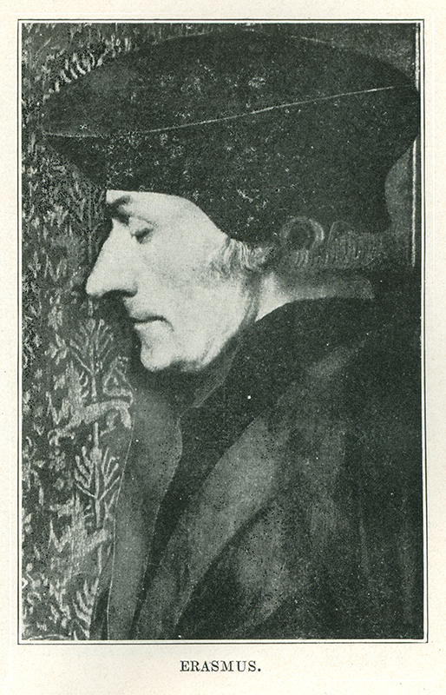 decidedly against doctrine and dogmas. To him, Christianity was an ethical affair. It meant being transformed in the heart to be a better person like Christ himself. He writes,

*“This kind of philosophy is situated more truly in the emotions than in syllogism, it is a life rather than a disputation, an afflatus rather than erudition, a transformation rather than reason. To be learned is the lot of only a few; but no one is unable to be a Christian, no one is unable to be pious, and I add this boldly, no one is unable to be a theologian. For that which is most of all in accordance with the nature descends easily into the minds of all. But what else is the philosophy of Christ, which he himself calls a rebirth, than the instauration of a well-founded nature?”[iii]*

*That might sound like something Luther would write, but these men and their ideas could not be farther apart. There is nothing here of the doctrine of justification by grace through faith. If anything, it rewords the corrupted doctrine of justification  that rests on an individual’s reparation of nature through works, in eloquent yet undogmatic language*.

For all his desire to see changes within the church, Erasmus still held tight to the prevailing errors of his day: the dignity of man and salvation that comes from cooperating with God’s grace by works. His loyalties to error and his great distaste for any sort of conflict in the church finally drove him to writes his Diatribe against Luther.

Erasmus refused to let the Scriptures speak clearly on doctrine, especially that of man’s bound will that cannot choose God and godliness. Erasmus writes,

*“There are some things which God has willed that we should contemplate, as we venerate himself, in mystic silence; and, moreover, there are many passages in the sacred volumes about which many commentators have made guesses, but no one has finally cleared up their obscurity: as the distinction between the divine persons, the conjunction of the divine and human nature in Christ, the unforgivable sin; yet there are others things which God has willed to be most plainly evident and such are the precepts for the good life.”[iv]*

This short list of “obscurities” are telling. They have everything to do with what we confess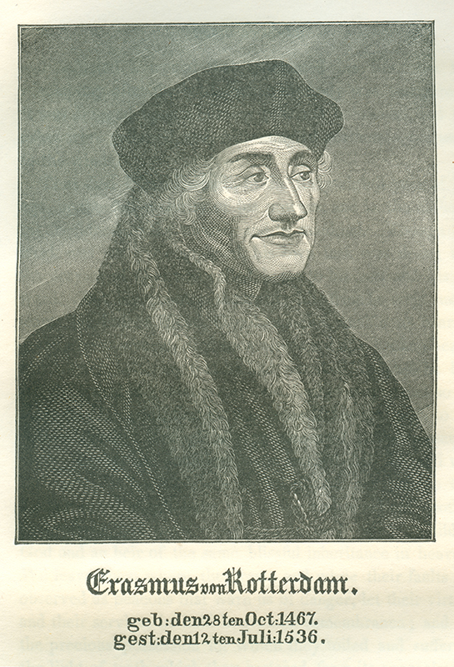 clearly in the creed and hold to by faith. Undogmatic indeed! Erasmus only has eyes and ears for the law, the precepts “for the good life”, as he calls it. What might be gleaned from the Scriptures about God’s work in the person of Christ and the faith that clings to his Word are nothing but fodder for “mystic silence.”

Luther refuses to concede the Scriptures as a book full of confused articles of doctrine. He desires clear and unequivocal assertions, assertions about the person and work of Christ, faith, and the inability of man to choose or work toward his salvation. Luther says in his response to Erasmus, On the Bondage of the Will, “The Holy Spirit is no Skeptic, and it is not doubts or mere opinions that he has written on our hearts, but assertions more sure and certain than life itself and all experience.”[v]

If you want to get to the heart of the conflict between Erasmus and Luther on the issues of faith, works, bound will, God’s foreknowledge, or anything else, then you must see the foundation upon which both men stand.

Erasmus was indeed a biblical scholar, but he so detested conflict that he refused to let the Scriptures speak for themselves. For all his love of eloquence, the Bible’s clarity meant little. His “Philosophy of Christ” was based on nothing more than what most people today would call “religion”: an inarticulate preoccupation with being a good person.

On this point, we would do well to recognize that Erasmus’ humanist legacy has overcome the Reformation in the judgments of individualistic modern western society. In that sense, Erasmus was a man ahead of his time. Luther’s love of theology and doctrine may have lost popularity, but that does not make him wrong. Despite the upheaval around him in the world, Luther fought because he knew that Jesus would not share his glory with our works. He desired the greater peace and unity not of this world, but of faith in Christ.

The Holy Ghost is no more a skeptic today as he was five hundred years ago. He asserts. He gives the Law not as a ladder to reach God (Ps. 143:2; Rom. 3:10), but to expose our weakness and sin (Rom. 3:20). He speaks the mercy and kindness of God as nothing earned, but as a free gift that we have for Christ’s sake (Rom. 3:22-25). The Lord does not mumble these truths in a corner. The Scriptures are meant to be asserted in preaching. The Scriptures teach that Christ, God’s true Son, died for you. This is a doctrine that demands and requires faith.

As heirs of the Reformation, we should not shy away from assertions and dogma, nor should we ignore the philological tools of the humanists that allow a clear reading of the Scriptures. Like our fathers in the faith we must hold to Christ’s teachings plainly set forth in the Bible.

Our redemption is found nowhere else. Luther says,

*“Neither you nor I could ever know anything about Christ, or believe in him and receive him as Lord, unless these were offered to us and bestowed on our hearts through the preaching of the gospel by the Holy Spirit. The work is finished and complete; Christ has acquired and won the treasure for us by his sufferings, death, and resurrection, etc. But if the work remained hidden so that no one knew of it, it would have been all in vain, all lost. In order that this treasure might not remain buried but be put to use and enjoyed, God has caused the Word to be published and proclaimed, in which he has given the Holy Spirit to offer and apply to us this treasure, this redemption.”[vi]*

The Rev. A. Brian Flamme is a pastor at Hope Lutheran Church, Aurora, Colo.

[i] Harold Grimm, The Reformation Era: 1500-1650 (New York: Macmillan, 1973), 65.

[ii] Grimm, 71

[iii] Erasmus, quoted in Lewis Spitz, The Renaissance and Reformation Movements: Vol. I (St. Louis: Concordia Publishing House, 1987), 297.

[iv] Erasmus, “On the Freedom of the Will: A Diatribe or Discourse,” in Luther and Erasmus: Free Will and Salvation, Edited by Gordon Rupp and Philip Watson (Philadelphia: The Westminster Press, 1969), 39-40.

[v] Luther, “On the Bondage of the Will,” in Luther and Erasmus: Free Will and Salvation, Edited by Gordon Rupp and Philip Watson (Philadelphia: The Westminster Press, 1969), 109.

[vi] LC, II, 38-39 (Kolb-Wengert, 436).